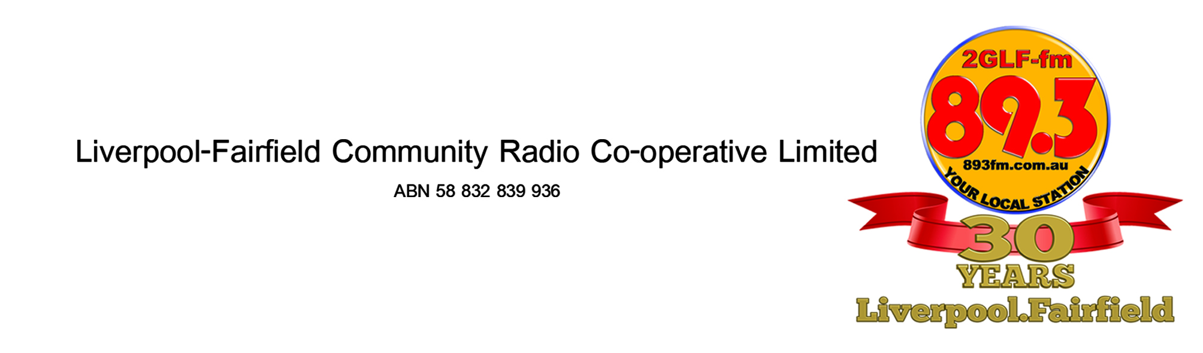

TRAINING COURSE OUTLINE
Commencing Monday 9th February 2015
Monday 9th February 2015 Week 1
7.00pm to 9.00pm
- Introduction to the course, radio sectors and where 2GLF fits into the overall broadcasting industry
Monday 16th February 2015 Week 2
7.00pm to 9.00pm
- Presenting on air
Monday 23rd February 2015 Week 3
7.00pm to 9.00pm
- Writing for radio
Monday 2nd March 2051 Week 4
7.00pm to 9.00pm
- Planning a program
Monday 9th March 2015 Week 5
7.00pm to 9.00pm
- Interviewing
Monday 16th March 2015 Week 6
7.00pm to 9.00pm
- Editing
Monday 23rd^{th} March 2015 Week 7
7.00pm to 9.00pm
- Media Law
Monday 30th March 2015 Week 8
7.00pm to 9.00pm
- Media Law and course round up

Practical Sessions
Panel training will be arranged at the first meeting on 9th February to accommodate most trainees. It will involve an additional evening at the 2GLF studios. Content of the panel training will be:

Session 1
An introduction to the panel
- Sources
- Inputs and Outputs
- Levels, Meters and Monitoring

Session 2
Panel Operation (Bring your headphones and some CDs)
- Program, Record and Cue
- Zero means Zero – The brick wall

Session 3
Microphone technique including reading a script
Reading with music under; how load should it be

Session 4
Different Microphones and their characteristics
- Polar Patterns – Which side is the front
- Protect your ears, protect the mic’s ears too

Session 5
Recording a Program segment
- Running Sheet
- Scripts
- What inserts do you need?

Session 6
Introduction to Simian
- Decks and Files
- Intros, Segues and Outros
- Cues
- The 4th Deck

Session 7
Simian Continued:
- Voice Tracking
- Preview and Review

Session 8
Recording a 20 minute segment for air play
This will be used to assess the skills you have gained through the training course

