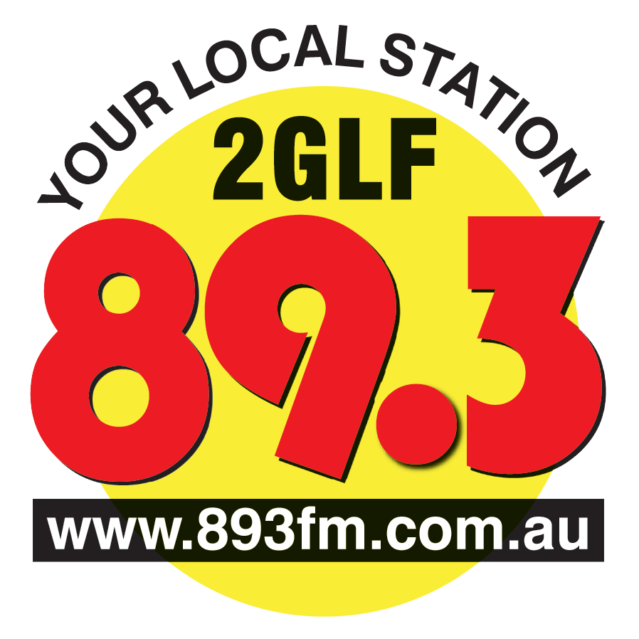
Liverpool-Fairfield Community Radio Co-operative Ltd
PO Box 531 Liverpool NSW 1871
T: 02 9601 4489
E: office@893fm.com.au

MEMBERS’ MEETING TUESDAY 12th MARCH 2013
HILDA M DAVIS CENTRE
185, Bigge St Liverpool
7.30pm to 9.30pm
AGENDA
- Apologies
- Opening
- Minutes of the meeting held on 16th October 2012
- Matters arising
- Update on the studios
- Work, Health and Safety
- Social Media Policy
- The process for rule changes
- General business

N.B this is a Members’ Meeting not a General Meeting of the Co-operative.

Yours sincerely,

Carol North-Samardzic
Secretary

