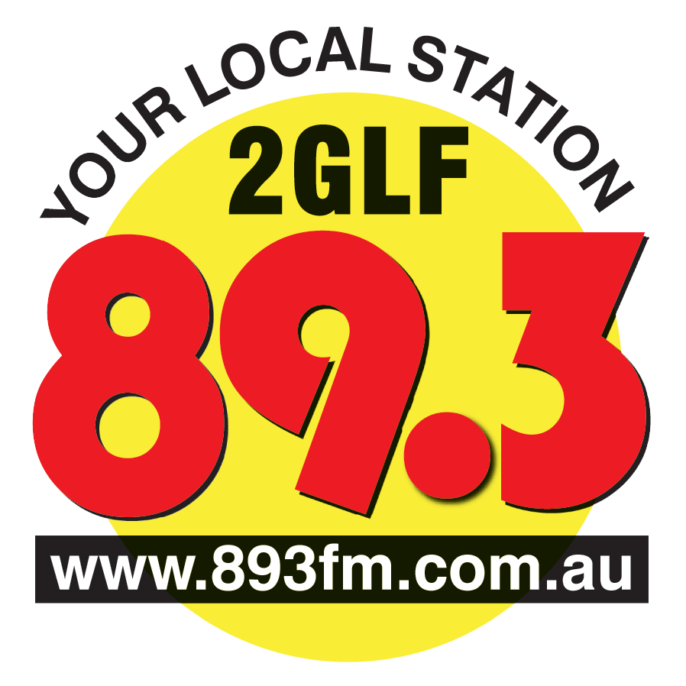
Liverpool-Fairfield Community Radio Co-operative Ltd
PO Box 531 Liverpool NSW 1871
T: 02 9601 4489
E: office@893fm.com.au

MEMBERS MEETING TUESDAY 16th OCTOBER 2012
HILDA M DAVIS CENTRE
185, Bigge St Liverpool
7.30pm to 9.30pm
AGENDA
The meeting will be chaired by Bill Phillips as the meeting is a Members Meeting not a General Meeting of the Co-operative.
- Apologies
- Opening
- Minutes of the meeting held on 26th June 2012
- Matters arising
- The election of the programming Committee 2012 -2013
The process will require anyone nominated to speak for three minutes on why he/she should be elected onto the programming committee
- Outside Broadcasts
- Security/Access in the future
- Update on the studios
- General Business

Next meeting:

Yours sincerely,

Carol North-Samardzic
Secretary
8/10/2012

